**Final Monolythic Project Pipeline**

1. First launch 4 server 3 servers on 5,10 amazon machine image

1 st server: Tomcat --- do the configuration , install java 11

2nd Jenkins server: install java -11 java17, git, maven, jenkins

3rd sonar server :install java 11 and sonar service

4th nexus server : install java 11 and nexus service using documentation given

Do passwordlessauthentication between Jenkins and tomcat

Tomcat server: managed apps: we could see application

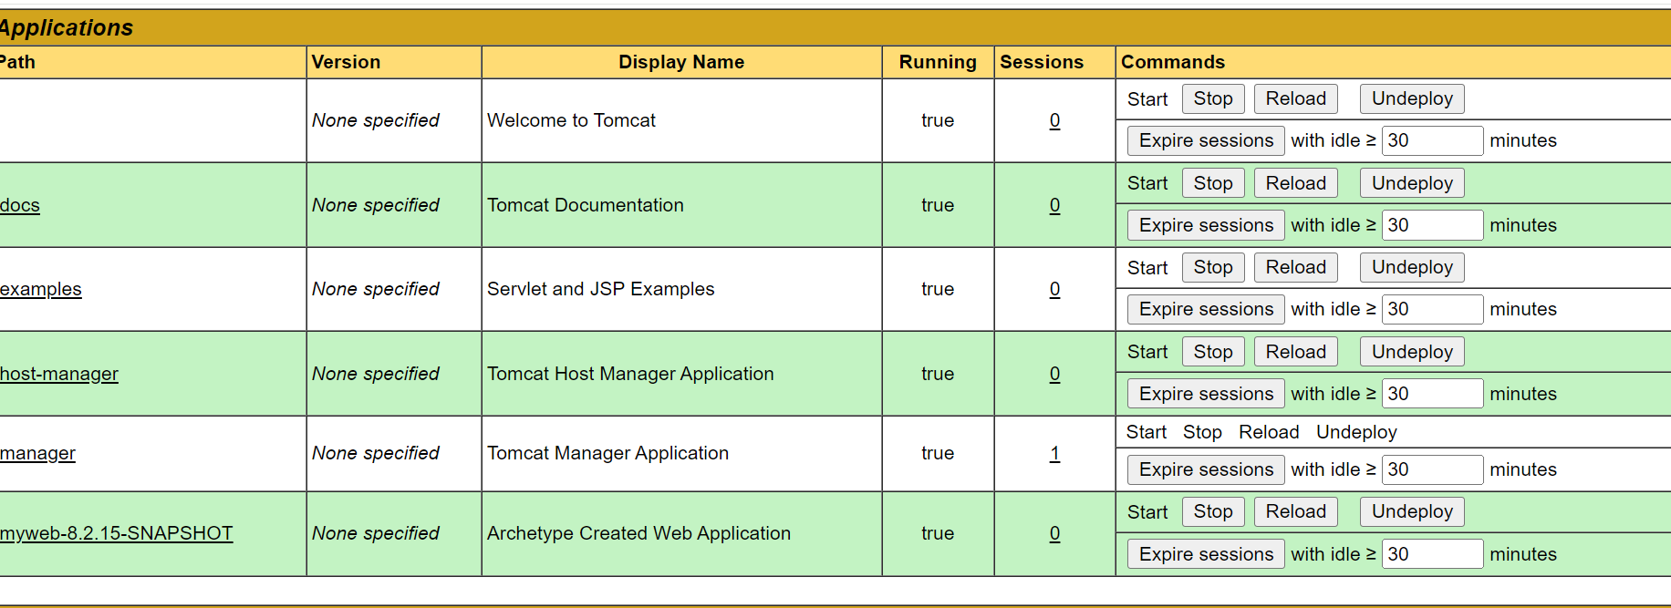

Under that application myweb deployed

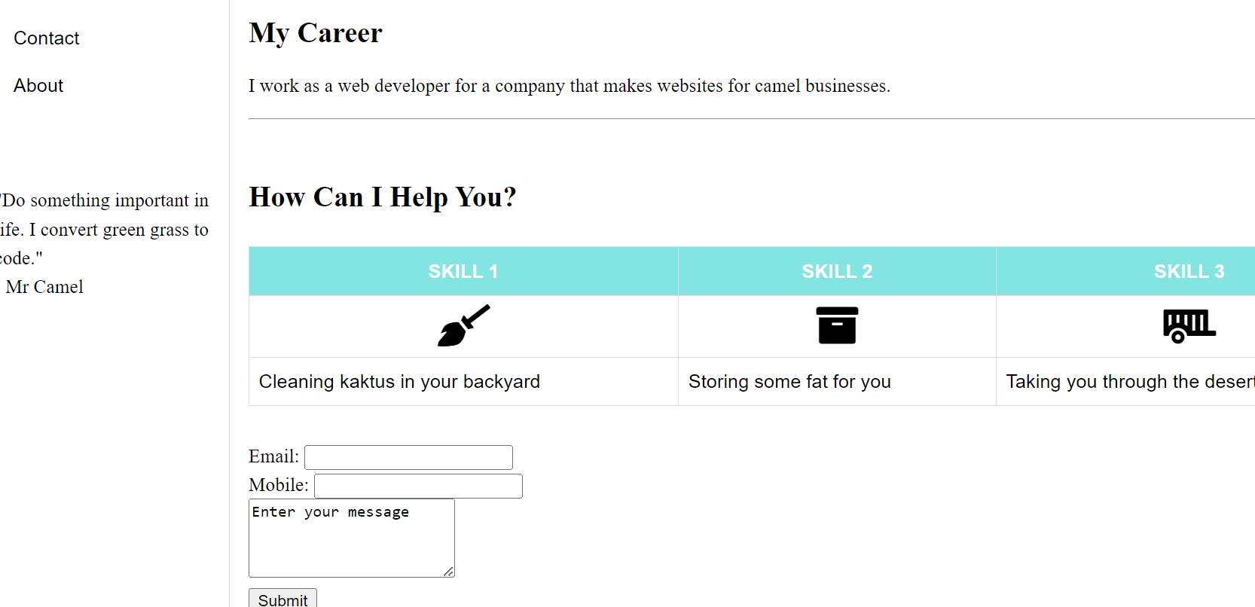

Nexus repository

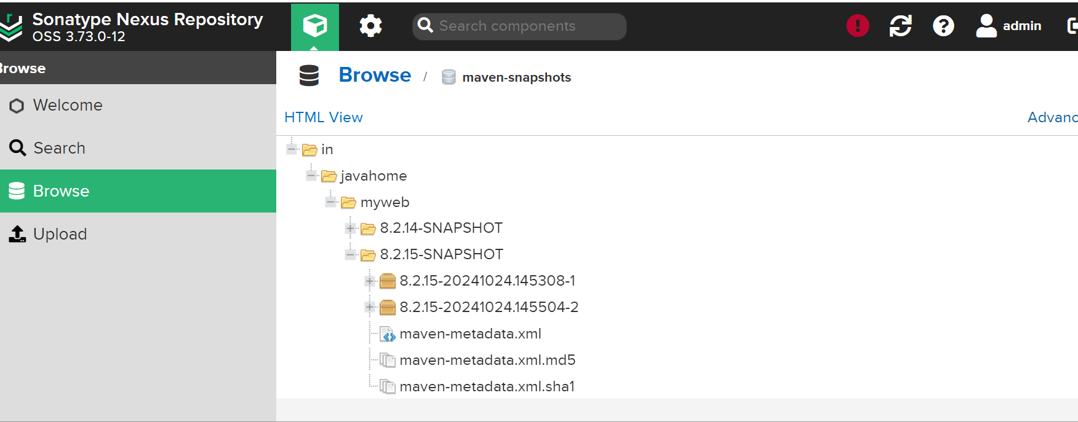

Build success

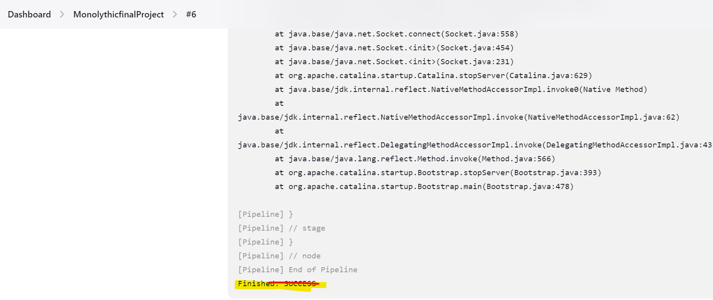

Pipeline stages:

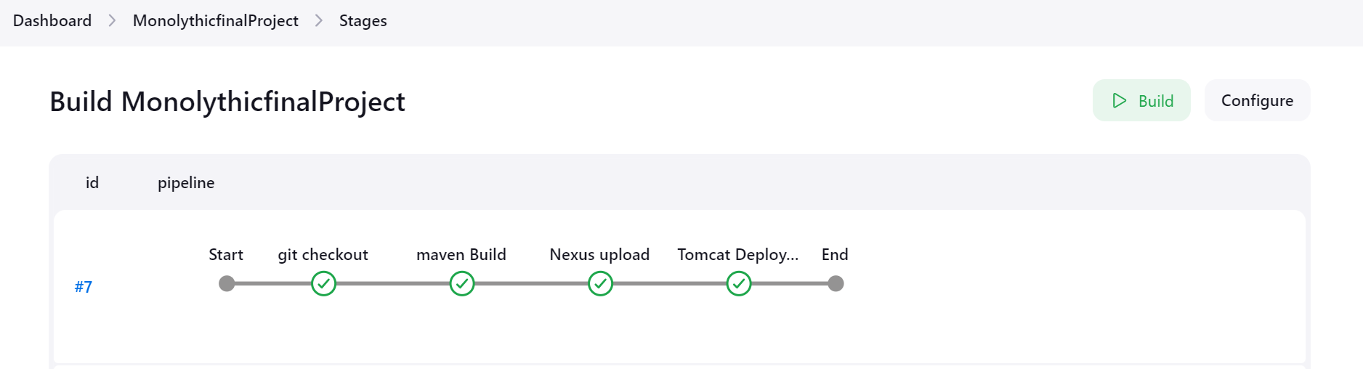

Pipeline:

pipeline {

agent any

stages {

stage('git checkout') {

steps {

git 'https://github.com/PrajaktaGi/myweb.git'

}

}

stage('maven Build') {

steps {

sh 'mvn clean package'

}

}

stage('Nexus upload') {

steps {

nexusArtifactUploader artifacts: [[artifactId: 'myweb', classifier: '', file: 'target/myweb-8.2.15-SNAPSHOT.war', type: 'war']], credentialsId: 'nexus3', groupId: 'in.javahome', nexusUrl: '172.31.9.76:8081', nexusVersion: 'nexus3', protocol: 'http', repository: 'maven-snapshots', version: '8.2.15-SNAPSHOT'

}

}

stage('Tomcat Deployment') {

steps {

sh """

ssh jenkins@172.31.2.235 sudo rm -rf /var/tmp/*.war

ssh jenkins@172.31.2.235 sudo rm -rf /opt/apache-tomcat-9.0.96/webapps/*.war

scp /var/lib/jenkins/workspace/MonolythicfinalProject/target/*.war jenkins@172.31.2.235:/var/tmp

ssh jenkins@172.31.2.235 sudo cp /var/tmp/*.war /opt/apache-tomcat-9.0.96/webapps/

ssh jenkins@172.31.2.235 sudo tomdown

ssh jenkins@172.31.2.235 sudo tomup

"""

}

}

}

}

https://github.com/lakshmiprasad2019/myweb/blob/master/pom.xml